Homework 3 for GPI
（The KK’s problems are referring to the e-copy on the internet classroom, their 1st edition； the number inside the () is the number of same problem in 2nd edition ）
- KK’s 2.4 （2.4）
- KK’s 2.11 (3.5)
- KK’s 2.12 (3.6)
- KK’s 2.14 (2.9)
- KK’s 2.16 (2.11)
- KK’s 2.19 (2.14)
- KK’s 2.22 (3.10)
- KK’s 2.24 (3.12)
- KK’s 2.26 (3.15)
- KK’s 2.30 (2.15)
- KK’s 2.33 (3.21)
- KK’s 2.34 (3.22)
- KK’s 2.37 (3.25)
- A bead is on a frictionless ring of radius R, the ring is rotating with angular velocity 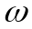:
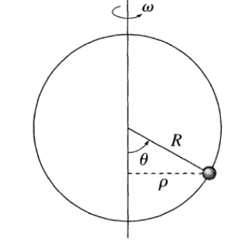
As the ring rotates, there are equilibrium positions for the bead, i.e. the angle could be kept at constant. Find the relation of the equilibrium positions of the bead with angular velocity of the ring, and discuss whether the equilibrium is stable or unstable, i.e. if there is a small displacement from the equilibrium, whether the bead will go back to equilibrium (stable case) or fly away from it (unstable).

